**Green Society Public School**

**D-06**

**Ratnanagar-7, Sauraha, Chitwan**

**Second Terminal Examination-2082**

**Class: Three Time: - 2 hrs. F.M.: 50**

**Sub: Maths**

|  |
| --- |
| **Name: Roll No.: Sec.:** |
| **­­­­­­­­­­­­ ________________ ______________ OBT.MARKS:**  **INVIGILATOR EXAMINER** |

**Group “A” (10×1 = 10)**

**1. Tick the correct answer:**

a) How many minutes are there in an hour?

i) 50mins ii) 60mins iii) 20mins

b) How many hours are there in a day?

i) 24hrs ii) 25hrs iii) 60hrs

c) 42 ÷ 6 =

i) 9 ii) 8 iii) 7

d). The numerator of 5/7 is

i) 5 ii) 6 iii) 7

e) The Roman numeral of 40 is

i) LL ii) XL iii) LX

f) The numeral of Two Thousand Sixty-Seven is

i) 2,067 ii) 2,607 iii) 2,600

g) How many zeroes are there in one thousand?

i) 4 ii) 2 iii) 3

h) 50 × 50 =

i) 25000 ii) 2500 iii) 250

i) What comes after 6984?

i) 6988 ii) 6985 iii) 6983

j) What comes between 7864 and 7866?

i) 7775 ii) 7867 iii) 7865

**Group “B” (12×2 = 24)**

**2. Multiply horizontally:**

a) 60 × 20 = __________ b) 40 × 30 = ___________

**3. Subtract vertically:**

2 0 9 8

5 6 3 4

5 6 7 4

4 5 2 3

**4) Add the following:**

a) 7604 + 2394 = ____________ b) 2741 + 1025 = _____________

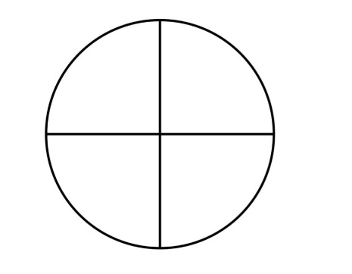**5) Colour the shapes to show the given fractions:**

|  |
| --- |
|  |
|  |

3

1

2

4

**6) Write down the numerator and denominator of the following fractions:**

|  |  |  |
| --- | --- | --- |
| Fraction | Numerator | Denominator |
|  |  |  |
| 9  4  3  2 |  |  |

**7) Arrange the data in descending order**:

7965 ,8069 ,9001 ,1025

_______ ________ _________ _________

**8) Fill the following number patterns in the boxes:**

20, 25, 30, _____, _____

1050, 1100, 1150, _____, _____

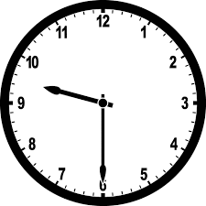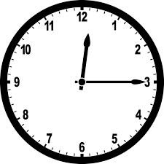**9) Find the time shown by the following clock.**

**10) Expand the following:**

a) 75,865 = _______________________________________________________

b) 52,060 = ______________________________________________________

**11) Fill in the blanks with <, > or =:**

a) 74,837 72,838 b) 23,354 23,354

c) 12,231 23,423 d)11,232 9,231

**12) Change into minutes:**

a) 7 hours b) 10 hours

**13) Write odd and even:**

65,401 = 44,000 =

72,813 = 88,446 =

**Group “C” (4×4 = 16)**

**14) Add the following:**

6 4 9 6

5 6 2 5

9 5 4 0

7 8 9 7

**15) Subtract the following:**

a) 7864 from 8642 b) 3948 from 7956

16) Multiply the following:

6 4 8

4 8

7 3

2 5

**17) Divide the following:**

0

9

2

4

9

6

7

8

**THE END**